Principal Component Analysis (PCA) Results
Generated: 2026-05-28 10:56:41

Parameters
Index | Parameter | Value
0 | Number of Components | 2
1 | Standardized | True
2 | Variables Used | Time, V1, V2, V3, V4, V5, V6, V7, V8, V9, V10, V11, V12, V13, V14, V15, V16, V17, V18, V19, V20, V21
3 | Observations | 30

Summary Statistics
Index | Statistic | Value
0 | Total Variance Explained | 38.16%
1 | Components Extracted | 2
2 | Original Variables | 31

Explained Variance
Index | Component | Variance Explained | Percentage | Cumulative %
0 | PC1 | 0.2522 | 25.22% | 25.22%
1 | PC2 | 0.1295 | 12.95% | 38.16%

Component Loadings
Index | PC1 | PC2
Time | 0.11341813060713103 | -0.044831245301518705
V1 | 0.13769497052335083 | -0.2733652515299909
V2 | 0.20094799982294248 | 0.20242767710932666
V3 | -0.1402838643188614 | 0.2184146163397631
V4 | -0.06909182268269605 | 0.24311681877235997
V5 | 0.018060326634932913 | -0.1479387180114202
V6 | -0.2326592601131125 | -0.04853343055976791
V7 | -0.09165366913511358 | -0.007382089674393481
V8 | -0.07313755545404385 | 0.030487768485181393
V9 | 0.08890426632595581 | -0.11270945856884555
V10 | -0.056026139069741326 | 0.1537432570682906
V11 | -0.03706026625146282 | -0.2167584817066377
V12 | 0.0032871270380490578 | 0.002384841475443833
V13 | -0.07919174902618951 | -0.09265268343046924
V14 | 0.055888543677739405 | -0.32943106061923305
V15 | -0.296269732979399 | 0.028966155198017637
V16 | 0.3209902706497859 | 0.11302489397485418
V17 | -0.26372601178886784 | 0.03217974840962945
V18 | 0.03000533550401628 | -0.12668414931479233
V19 | 0.2196233221049002 | 0.3261510374304403
V20 | -0.19156062671815108 | 0.2673004632268484
V21 | -0.10685633695014757 | -0.1534289087599574
V22 | -0.2600571873370582 | -0.008647971272151417
V23 | -0.2993617946725447 | -0.09192633646905803
V24 | 0.23056164883704092 | 0.2555049471243407
V25 | 0.2661976690585689 | -0.0010836121557325268
V26 | 0.23006466492186575 | -0.24505152044584957
V27 | 0.019179324361581134 | 0.37321460290426006
V28 | 0.179571093131845 | -0.20843905179573977
Amount | -0.2981512806837792 | -0.033924987395220374
Class | -0.0 | -0.0

Principal Component Scores
Index | PC1 | PC2
0 | -2.3485424694560026 | 4.381204826694659
1 | 2.393609149646808 | -2.677197056861659
2 | -13.86900252923808 | -2.705422029250314
3 | 0.6054187319181823 | -3.2768349053457477
4 | -0.7946728491373514 | 4.258448891398567
5 | -0.7023340552534527 | 3.273279612522321
6 | 1.1126999083486886 | -2.1197510707524825
7 | 1.3139310470949217 | 0.30536473391678215
8 | 1.0385563749432642 | -0.6471956495195638
9 | -1.3930976553559054 | 2.564355504889532
10 | 1.2754647498940797 | -1.5074766982514427
11 | 1.6497080983991474 | -1.3723948020316423
12 | 0.6877300704444625 | 0.20013757527000522
13 | 0.18644133712547956 | -0.49938672192016476
14 | -0.18352347750746423 | 2.8556639154528485
15 | 0.7940599341440117 | -0.5834702146514468
16 | -0.2183863345358589 | 1.2901779755753402
17 | 0.33134615582419114 | -0.6266337207384146
18 | 0.5613548935016576 | 1.041213997450547
19 | 0.8727507983839515 | -0.9980857533041253
20 | 0.10105206442185055 | 0.5639811865041138
21 | 1.159900727783917 | -1.0893763205024949
22 | 1.0594078448172417 | -0.6708514469176337
23 | 0.38266636336092097 | 1.1438153077584623
24 | 1.4360979240620086 | -0.45316277264124993
25 | 1.4908681296689443 | -1.1320500603181005
26 | -0.7705630007615689 | -1.8589170932398649
27 | 0.7536373074850697 | -1.1121874692016103
28 | 0.049535474889719024 | -0.7050721001382328
29 | 1.0238852850871607 | 2.157822358153005

Visualizations
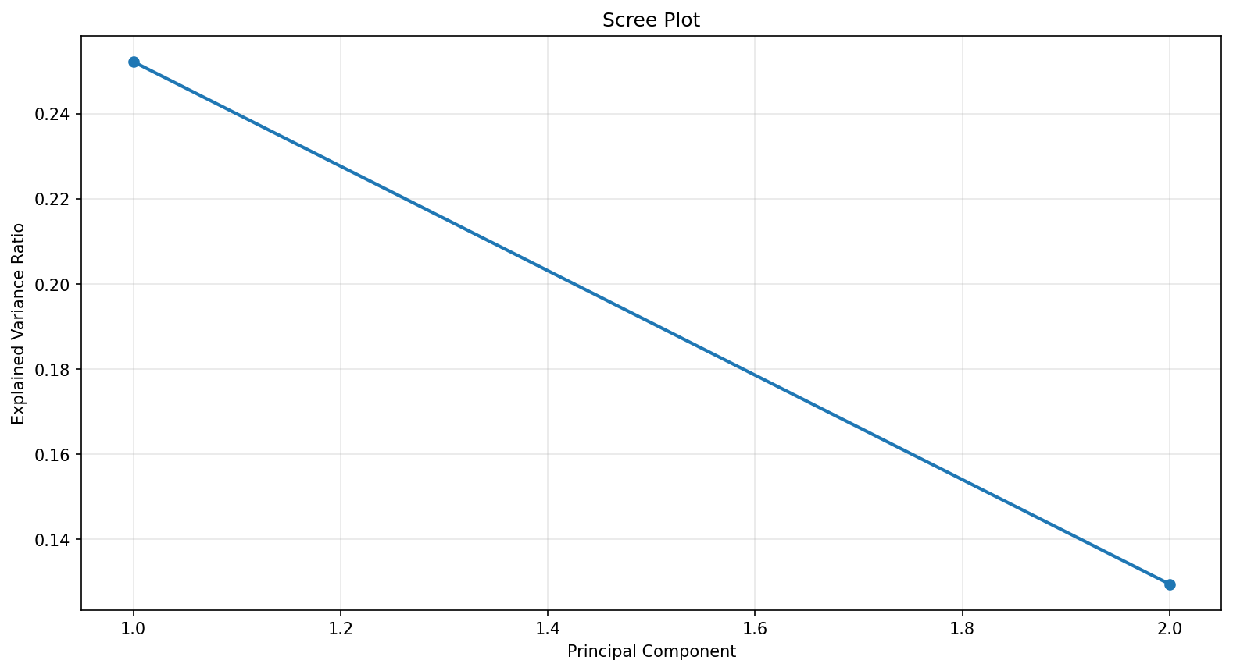
Figure 1

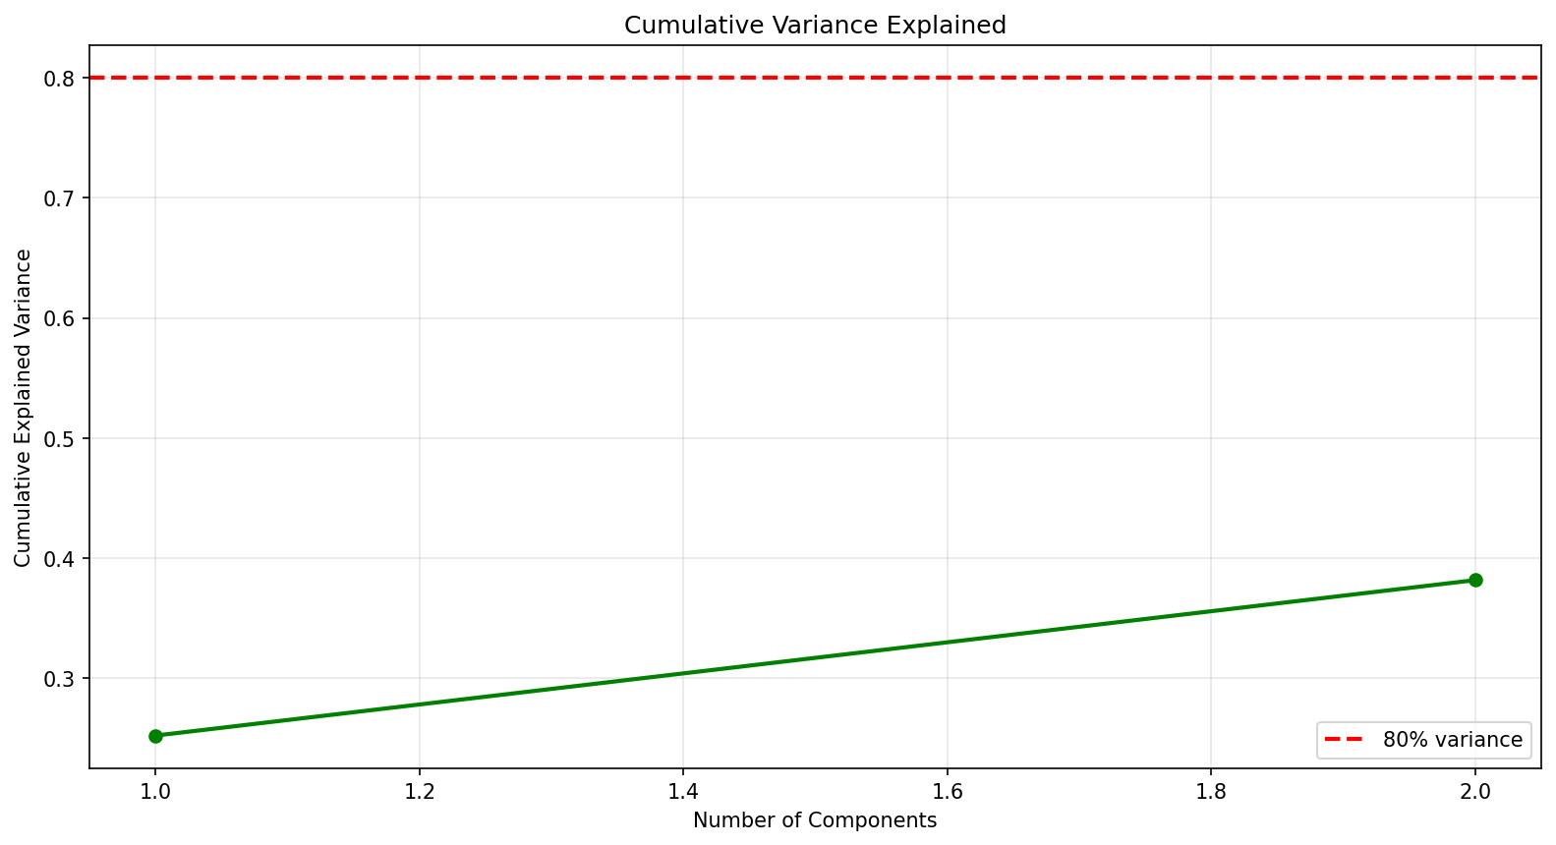
Figure 2

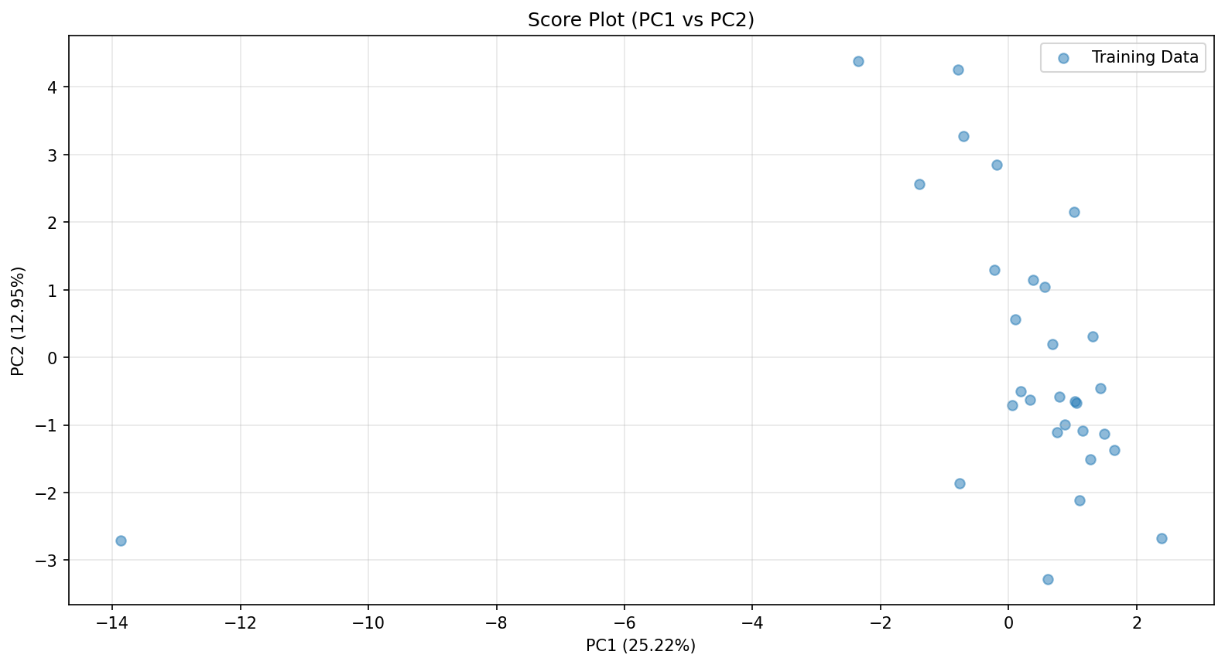
Figure 3

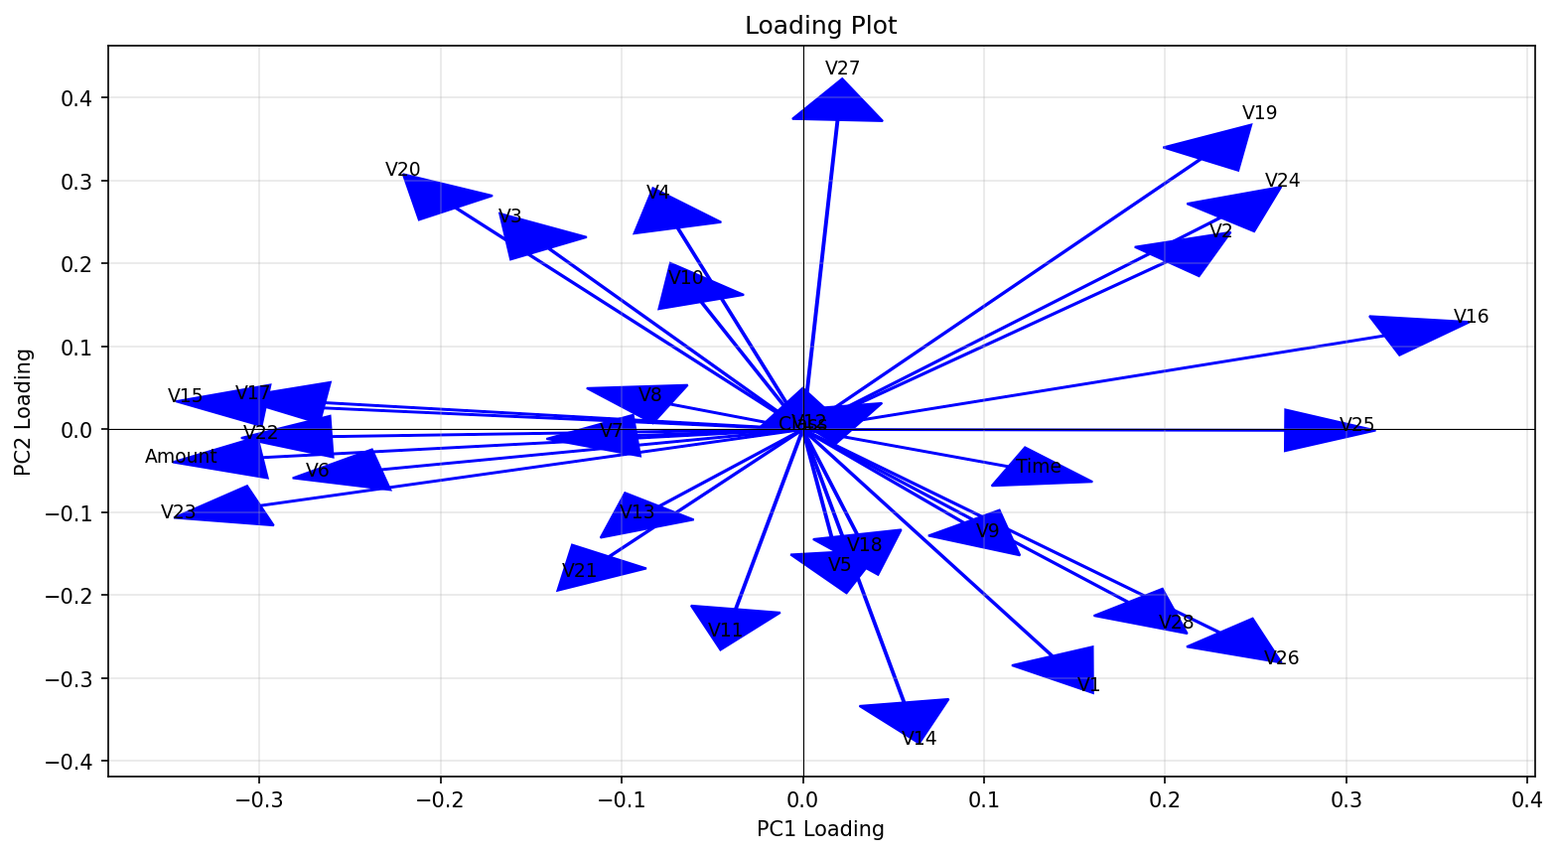
Figure 4

